**Report On Summer Olympics Analysis Project**

**Aim**

The aim of the project is to gain insight on trends in the Summer Olympic games since its inception. Some of the questions I sought to answer are:

1. Which country has hosted the Olympic games the most?
2. Which continent has hosted the Olympic games the most?
3. Which continent has never hosted the games?
4. What has been the male to female representation at the Olympics?
5. Which countries have participated in the games the most?
6. Which countries have won the most medals?

**The Dataset**

Four datasets in all where used for the projects. I decided on the data I would require for the questions I sought to answer and then obtained them by using BeautifulSoup to scrape data on some websites including Wikipedia, worldpopulationreview.com and whereig.com.The datasets where scraped and then read into a pandas dataframe. At the end, I had one dataset each on host countries, athletes, medals won and participating countries.

**Cleaning the Datasets**

After I had gotten the data, I had to carry out some cleaning tasks to get the data ready for analysis. This included things like dropping irrelevant rows and columns, renaming columns and filtering rows based on specified values. The data cleaning was done using pandas.

**Analysing The Data**

Once the data was all cleaned up and ready to go, it was time to carry out the analysis. This was also done using pandas while the results where visualised using seaborn.

The Results

1. Which countries have hosted the Olympic games the most?

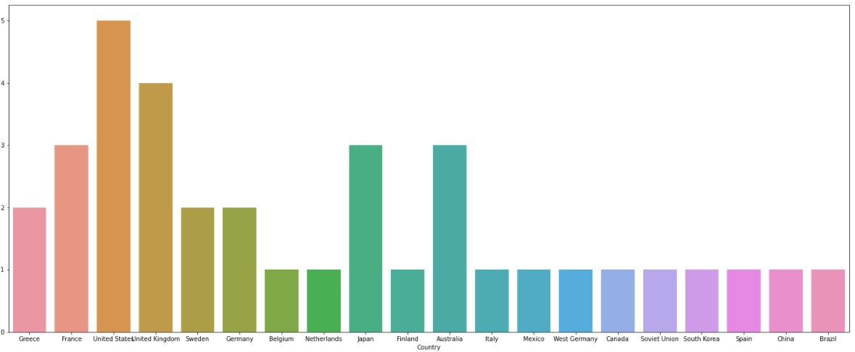  
Fig. 1 Top 20 country host of the Olympic games

The chart clearly shows that the United States have hosted the games the most (a total of 5 times) followed by the United Kingdom (4 times) and France (3 times)

1. Which continent has hosted the games the most?

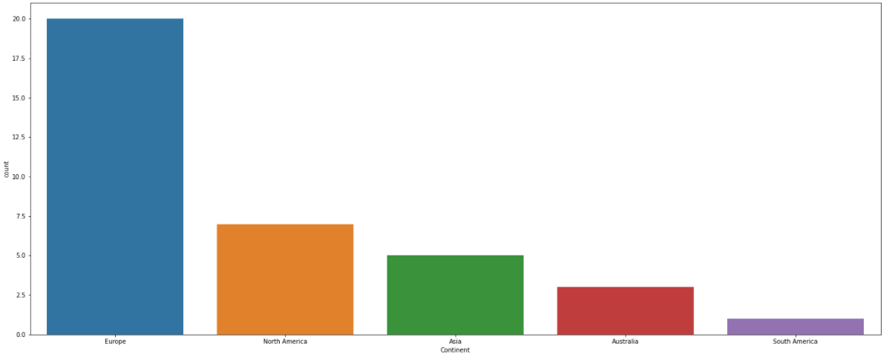

Fig. 2 Olympic games hosting by continent

We see that Europe has hosted the Olympic games the most (a total of 20 times)

1. Which continent has never hosted the games?

Fig 2 also shows us clearly that Africa has never hosted the Olympic games

1. What has been the male to female representation at the Olympics?

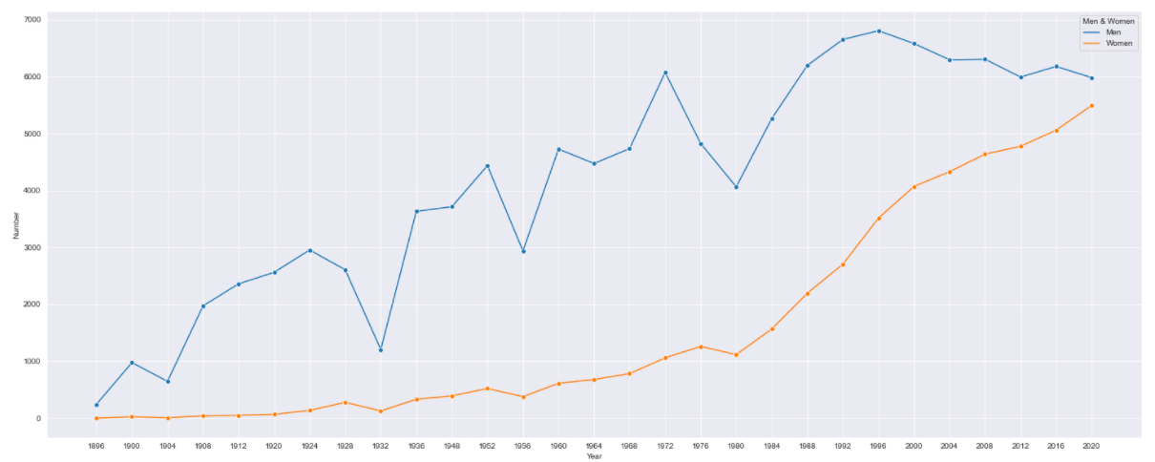

Fig. 3 Male to Female representation at the Olympics

Over the years, there has been a wide gap in male and female representation at the Olympics, however in recent times, that gap has been closing up with the recent Tokyo 2020 games having almost equal male and female participation

1. Which countries have participated in the games the most?

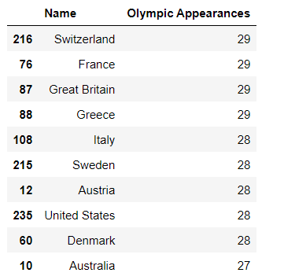

Fig. 4 Country participation in the Olympic games.

Switzerland, France, Great Britain and Greece have participated in all 29 of the Summer Olympic games

1. Which countries have won the most medals?

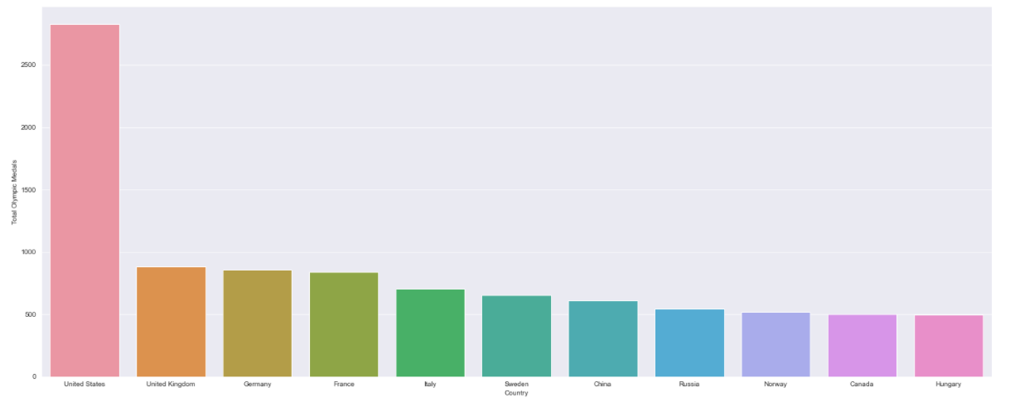

Fig. 5 Olympic games medal won by country

The United States has won the most medals followed by the United Kingdom and Germany

**Conclusion**

I enjoyed working on this project and wanted to show my skills in web scraping, data cleaning and analysis in pandas and data visualisation in seaborn.

I would like to see a Summer Olympic games hosted in Africa in the near future and come Paris 2024, I hope we have an equal number of male and female participants.